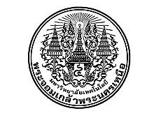

**Project Report Certificate**

**Faculty of Engineering, King Mongkut’s University of Technology North Bangkok**

Title Smart Power Meter by IoT System

By Mr.Thanaphol Suakong

Mr.Jirachat Yamsang

Mr.Natthapon Paresri

Accepted by the Faculty of Engineering, King Mongkut’s University of Technology North Bangkok in Partial Fulfillment of the Requirements for the Bachelor of Engineering in Instrumentation System Engineering.

….………………..……………………………….Dean of Faculty of Engineering

(Associate Professor Dr.Udomkiat Nontakaew)

Project Report Committee

………………………………………………………………………… Chairperson

(Assistant Professor Dr.Natee Thong-Un)

………………………………………………………………………… Member

(Assistant Professor Dr.Chirdpong Deelertpaiboon)

………………………………………………………………………… Member

(Mr.Noppadol Pudchuen)